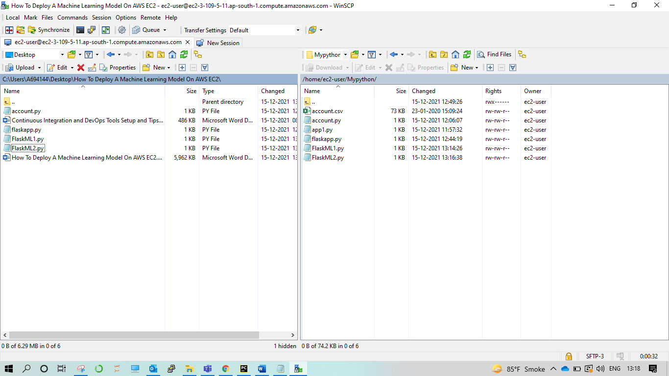

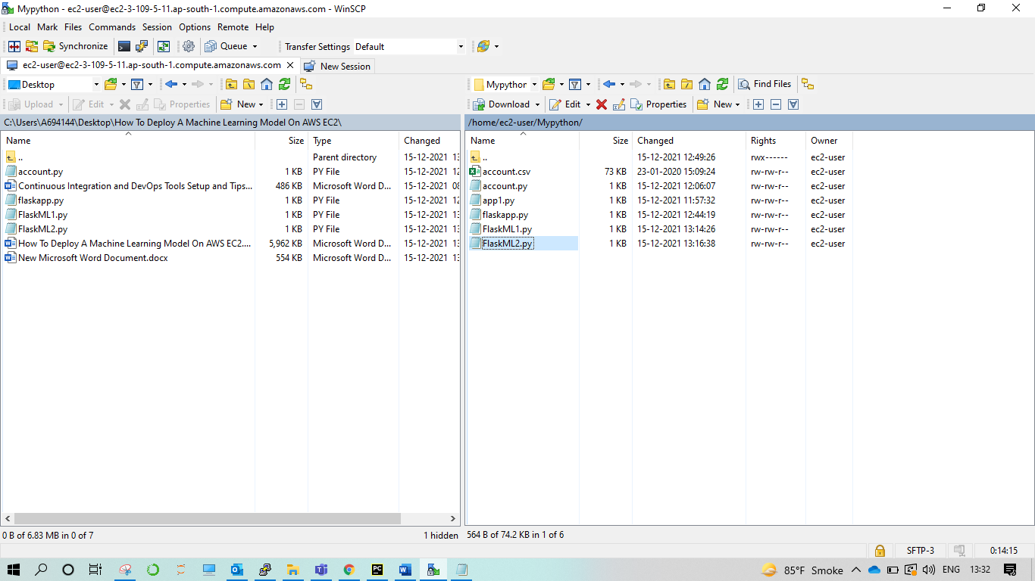

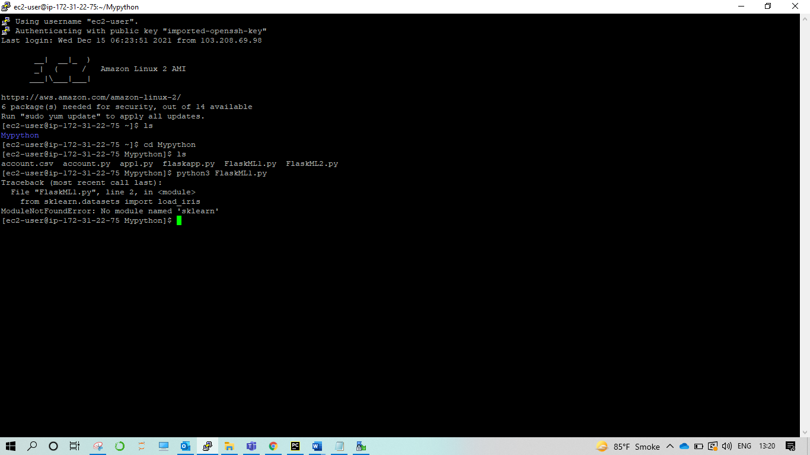

**pip3 install sklearn**

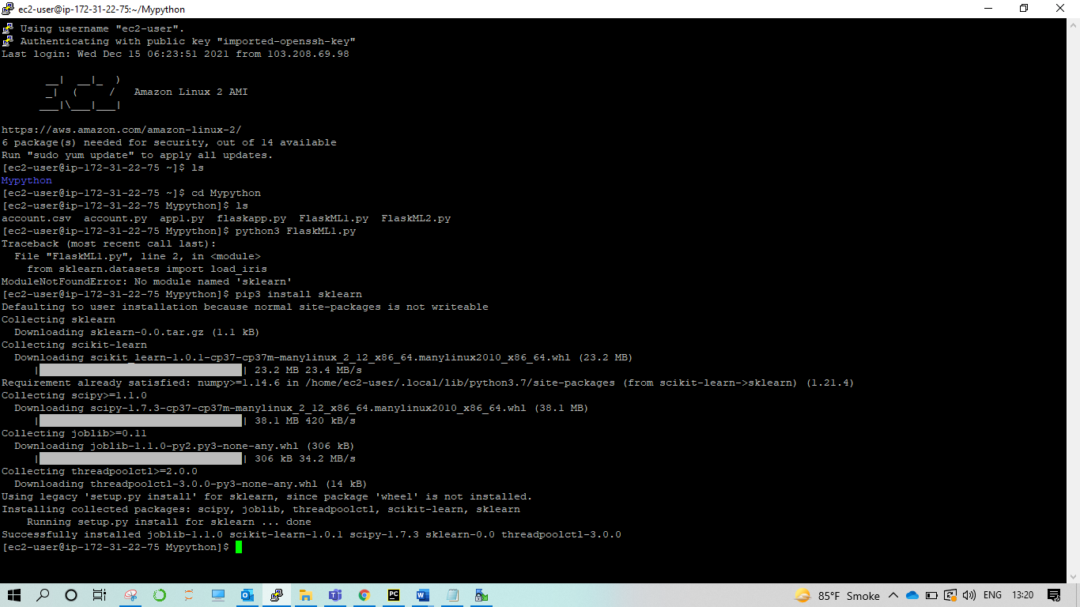

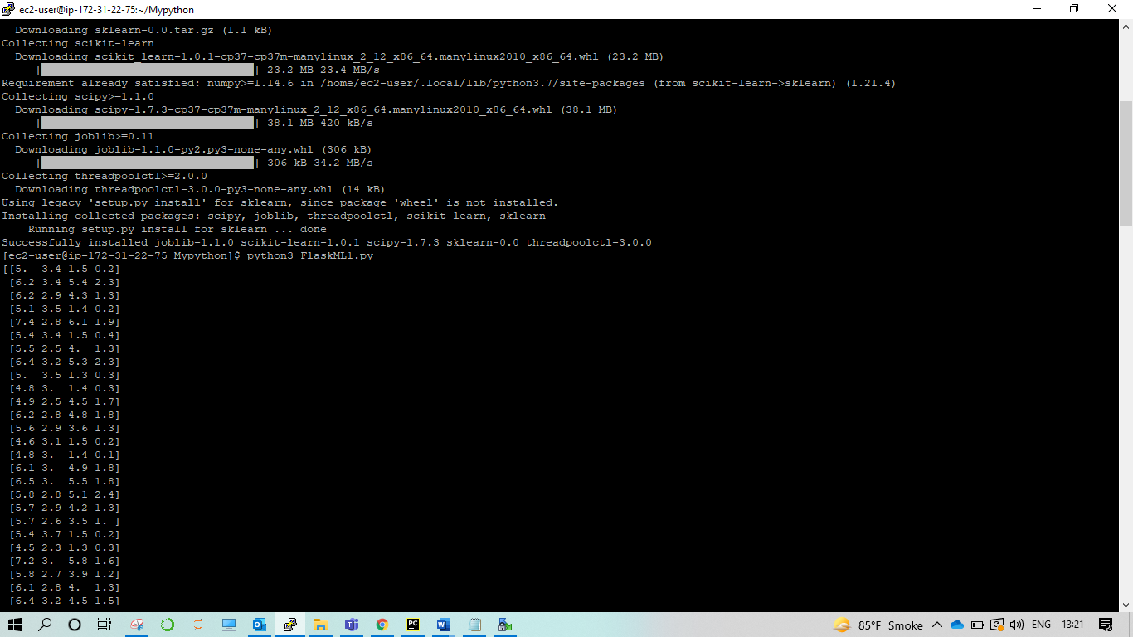

# load the iris dataset as an example

from sklearn.datasets import load_iris

iris = load_iris()

# store the feature matrix (X) and response vector (y)

X = iris.data

y = iris.target

#print(X)

#print(y)

# splitting X and y into training and testing sets

from sklearn.model_selection import train_test_split

X_train, X_test, y_train, y_test = train_test_split(X, y, test_size=0.2)

print(X_train)

print(y_train)

print(X_test)

print(y_test)

# training the model on training set

from sklearn.neighbors import KNeighborsClassifier

knn = KNeighborsClassifier(n_neighbors=3)

knn.fit(X_train, y_train)

# making predictions on the testing set

y_pred = knn.predict(X_test)

print(y_pred)

# comparing actual response values (y_test) with predicted response values (y_pred)

from sklearn import metrics

print("kNN model accuracy:", metrics.accuracy_score(y_test, y_pred))

import pickle

with open("knn.pkl",'wb') as model_pkl:

pickle.dump(knn,model_pkl)

===***************========

FlaskML1.py

=====************=========

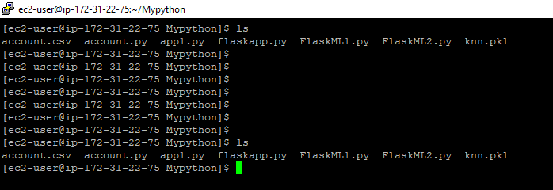

Pickle file generated successfully…. 😊

**from flask import Flask,request**

**import numpy as np**

**import pickle**

**with open('knn.pkl','rb') as model_file:**

**model=pickle.load(model_file)**

**app=Flask(__name__)**

**@app.route('/predict')**

**def predict_iris():**

**s_length = request.args.get("s_length")**

**s_width = request.args.get("s_width")**

**p_length = request.args.get("p_length")**

**p_width = request.args.get("p_width")**

**prediction=model.predict(np.array([[s_length,s_width,p_length, p_width]]))**

**return str(prediction)**

**if __name__=='__main__':**

**app.run(host='0.0.0.0',port=8080)**

===***************========

FlaskML2.py

Above is FlaskML2 code………

=====************=========

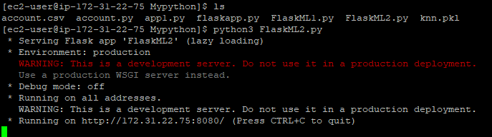

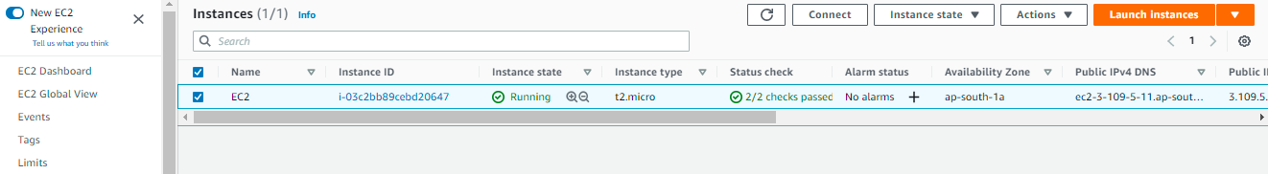

Click on Connect…. 😊

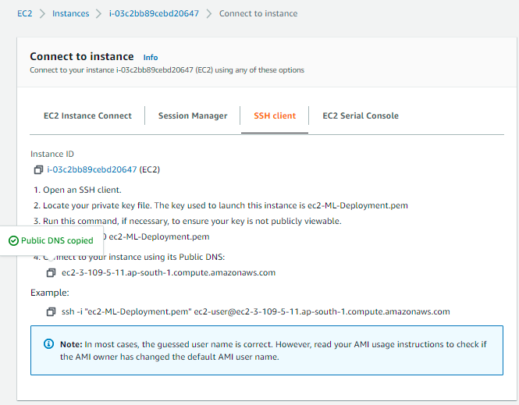

http://[ec2-13-127-234-4.ap-south-1.compute.amazonaws.com/predict?s_length=6.0&s_width=3.4&p_length=4.5&p_width=1.6](http://ec2-3-109-5-11.ap-south-1.compute.amazonaws.com:8080/predict?s_length=6.0&s_width=3.4&p_length=4.5&p_width=1.6)

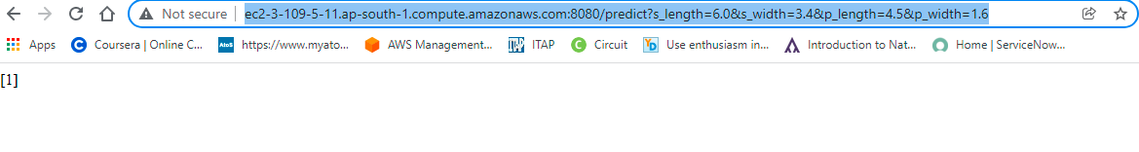

Congratulations…. 😊